# CS 255 System Design Document Template

## UML Diagrams

### UML Use Case Diagram

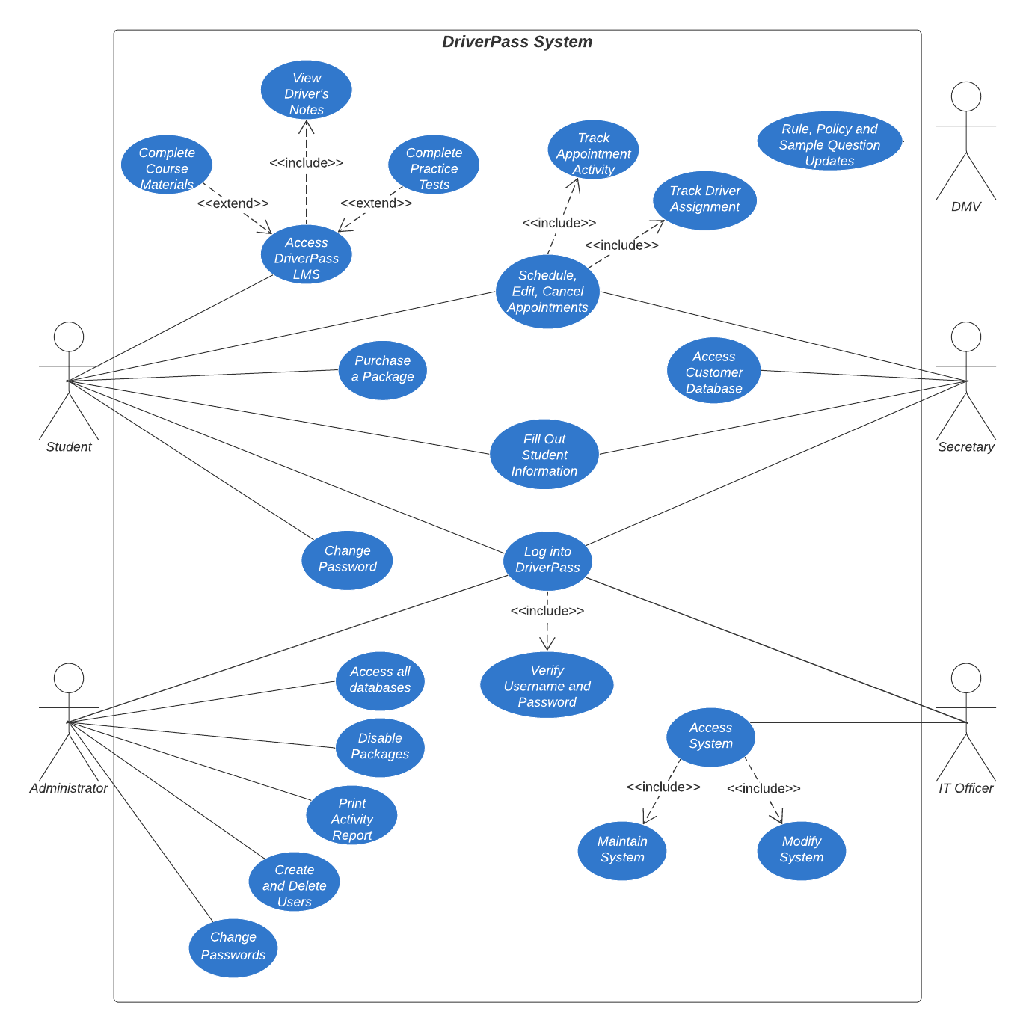

### UML Activity Diagrams

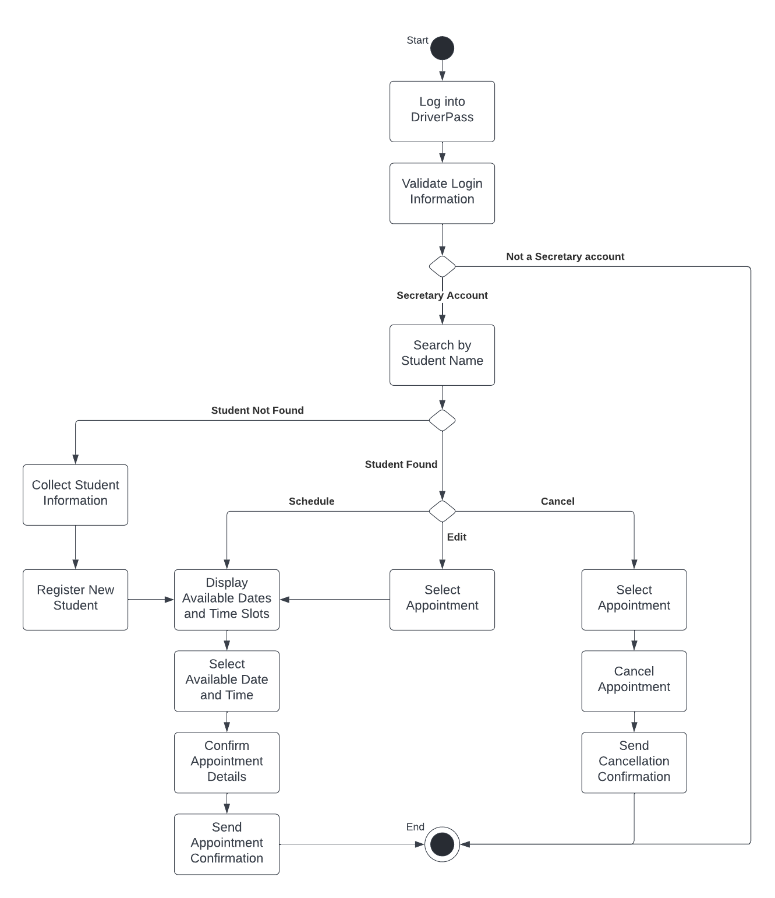

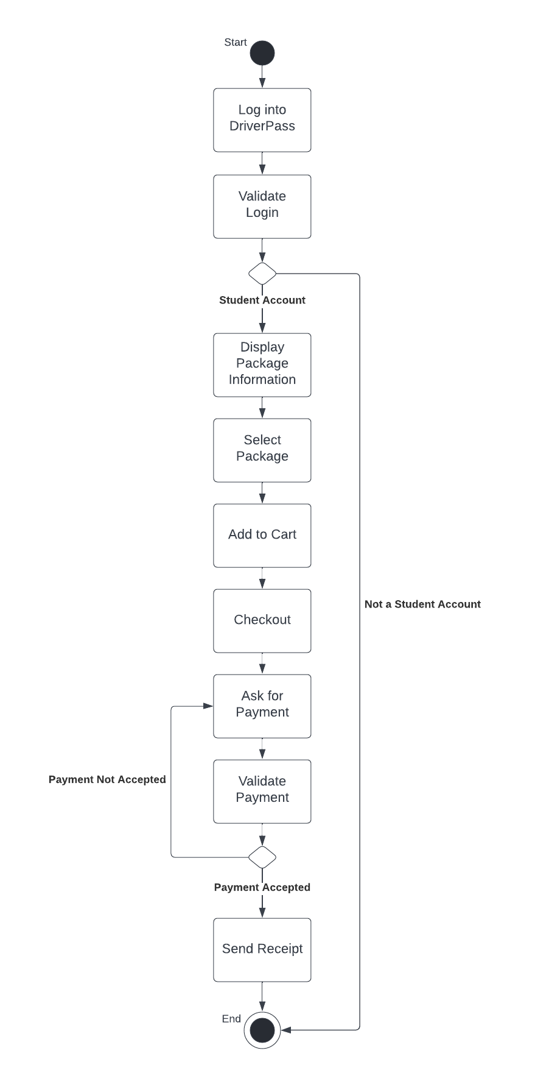

### UML Sequence Diagram

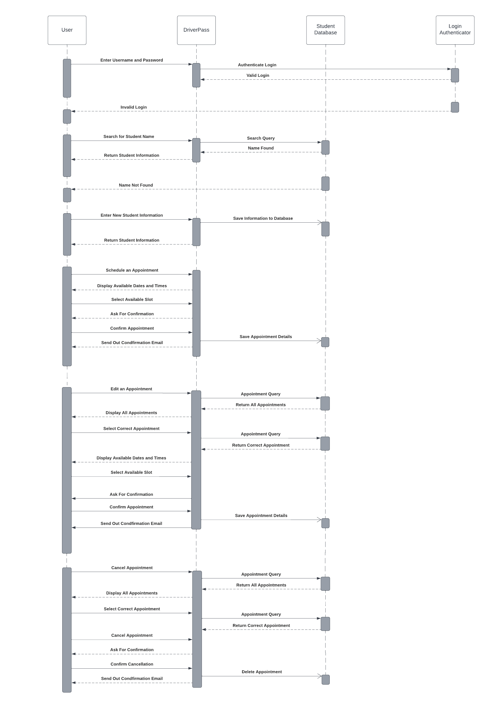

### UML Class Diagram

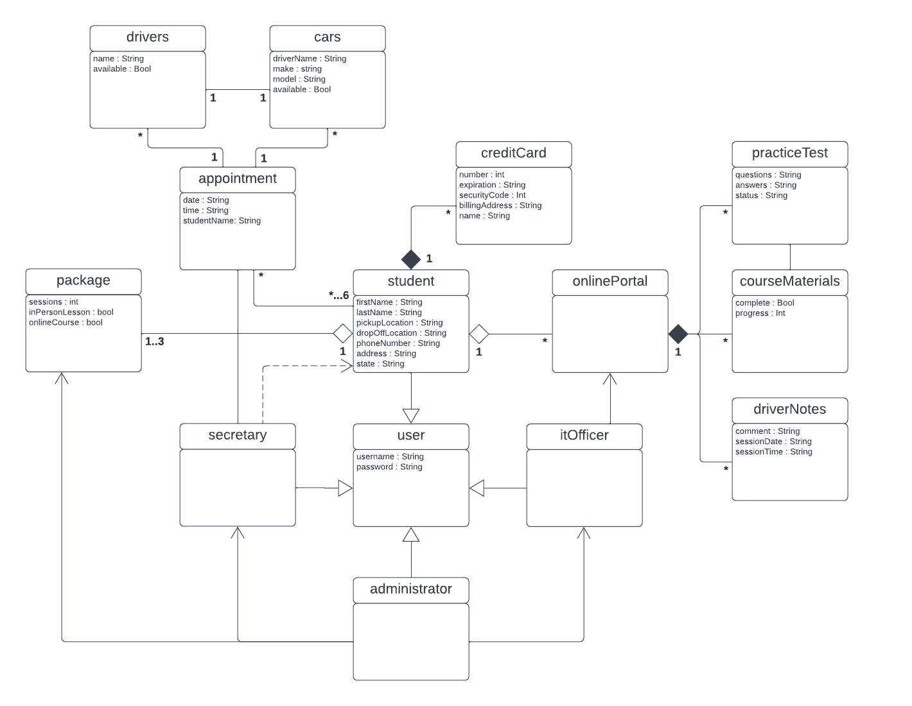

## Technical Requirements

The system will be cloud-based, so there needs to be a cloud server, cloud data stores and cloud-based backups. This can be set up on any computer. Once the system is up and running, it will be able to run on any browser. Any user will be able to access the system from a device with an internet connection. The system will need to have a portal for students to log into where they can access the online course materials and their driver’s notes from their sessions.